Adding a request and select the method as post

Script are written in tests,we created a environment variable as “owner” in tests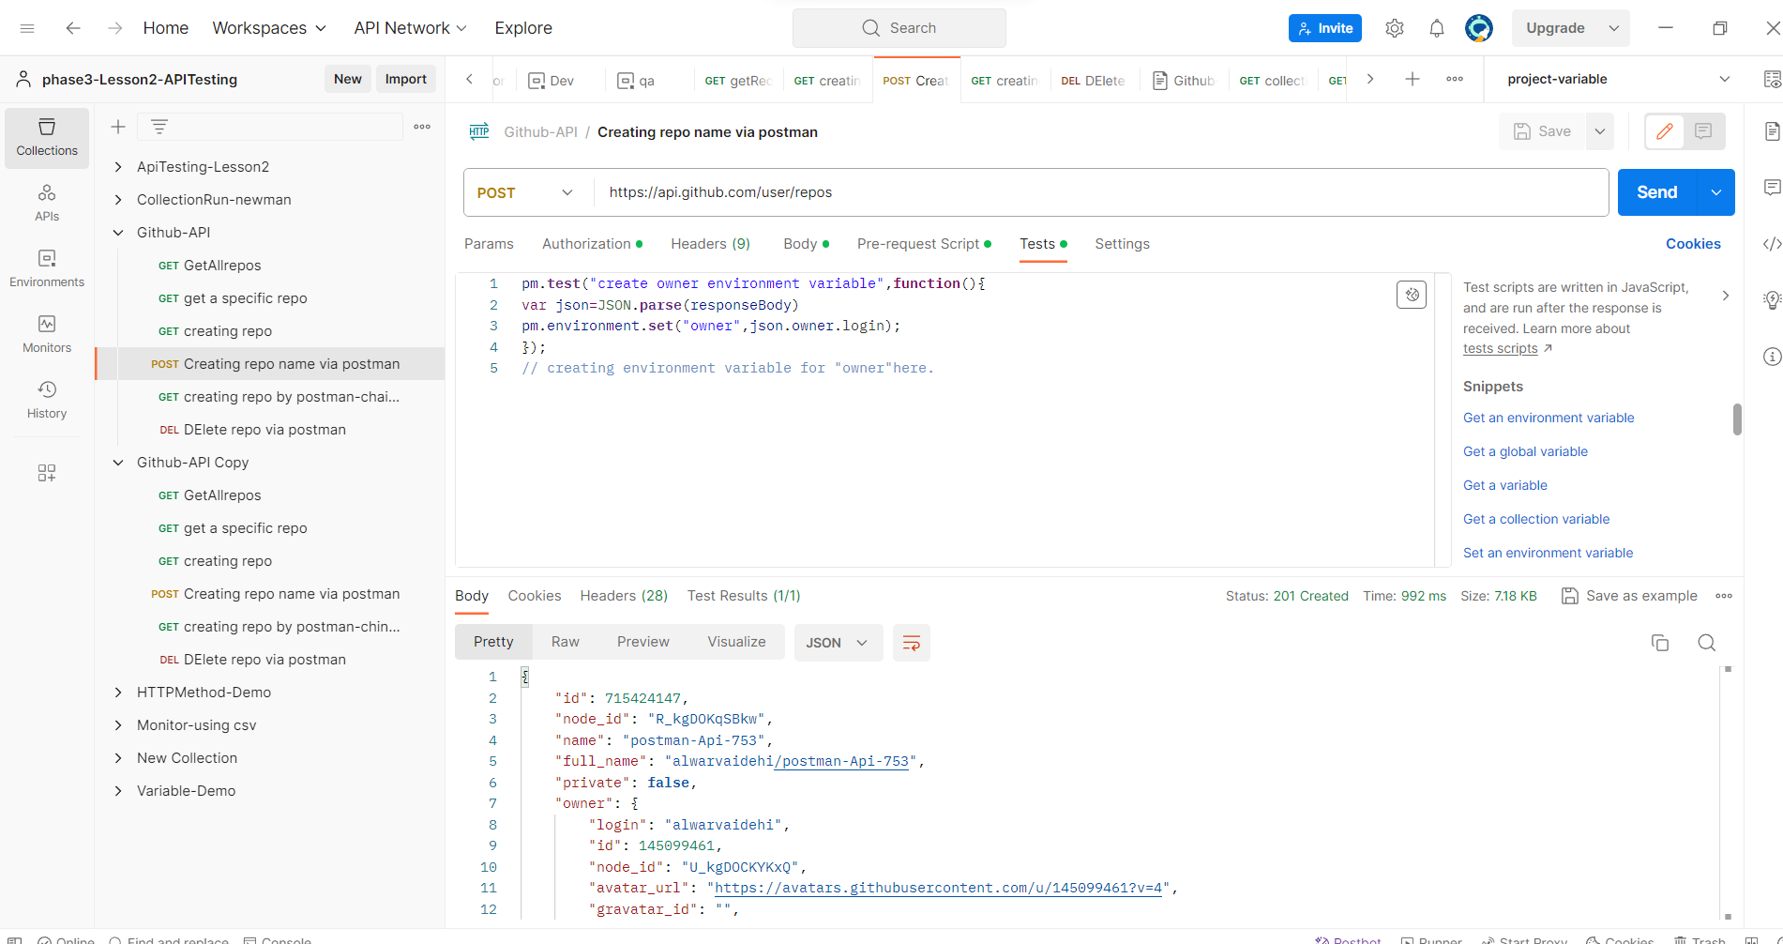

Github token is given in authentication to access the github through postman.

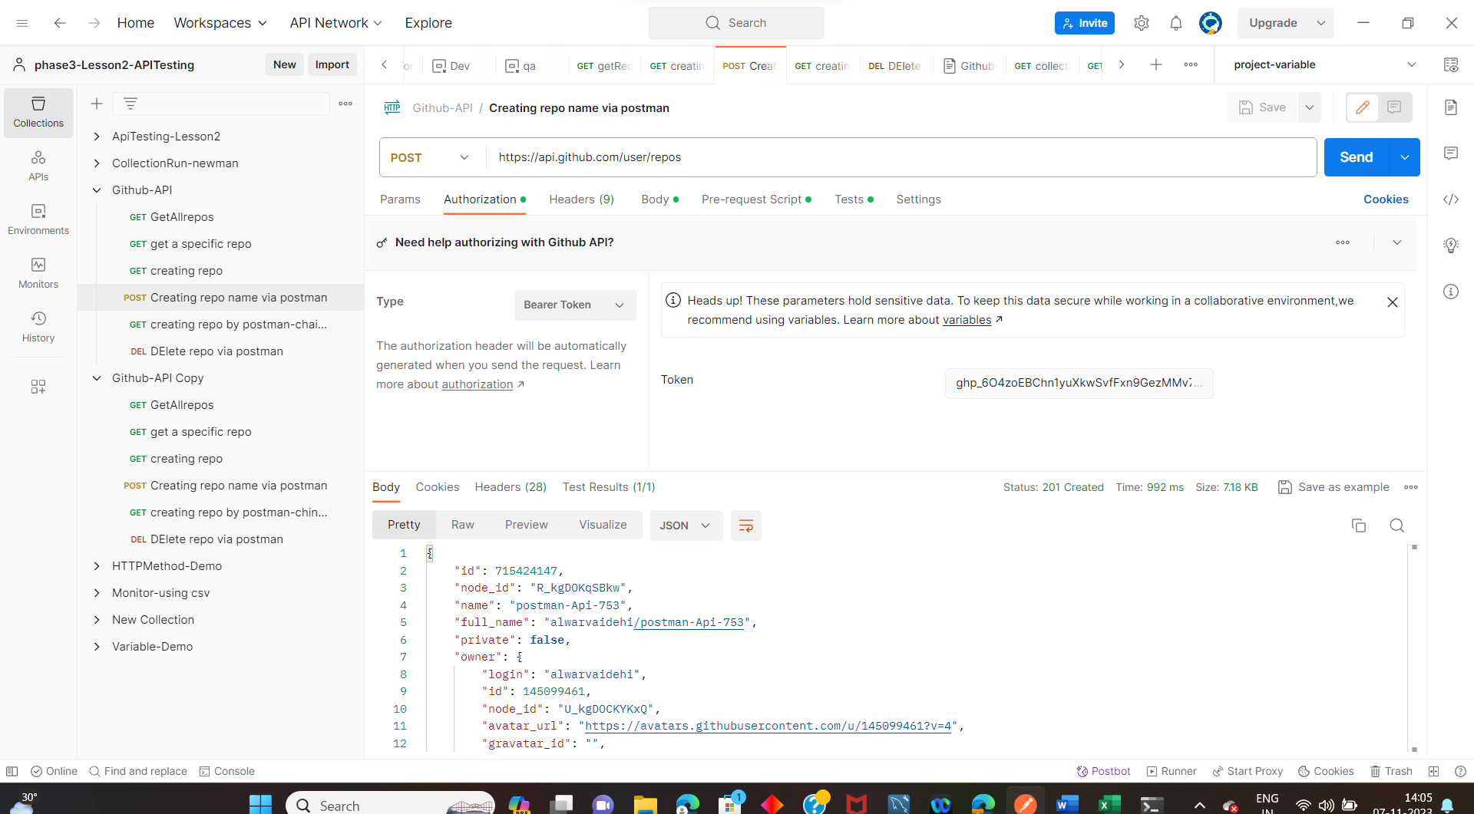

In body ,to create a repo in github code is written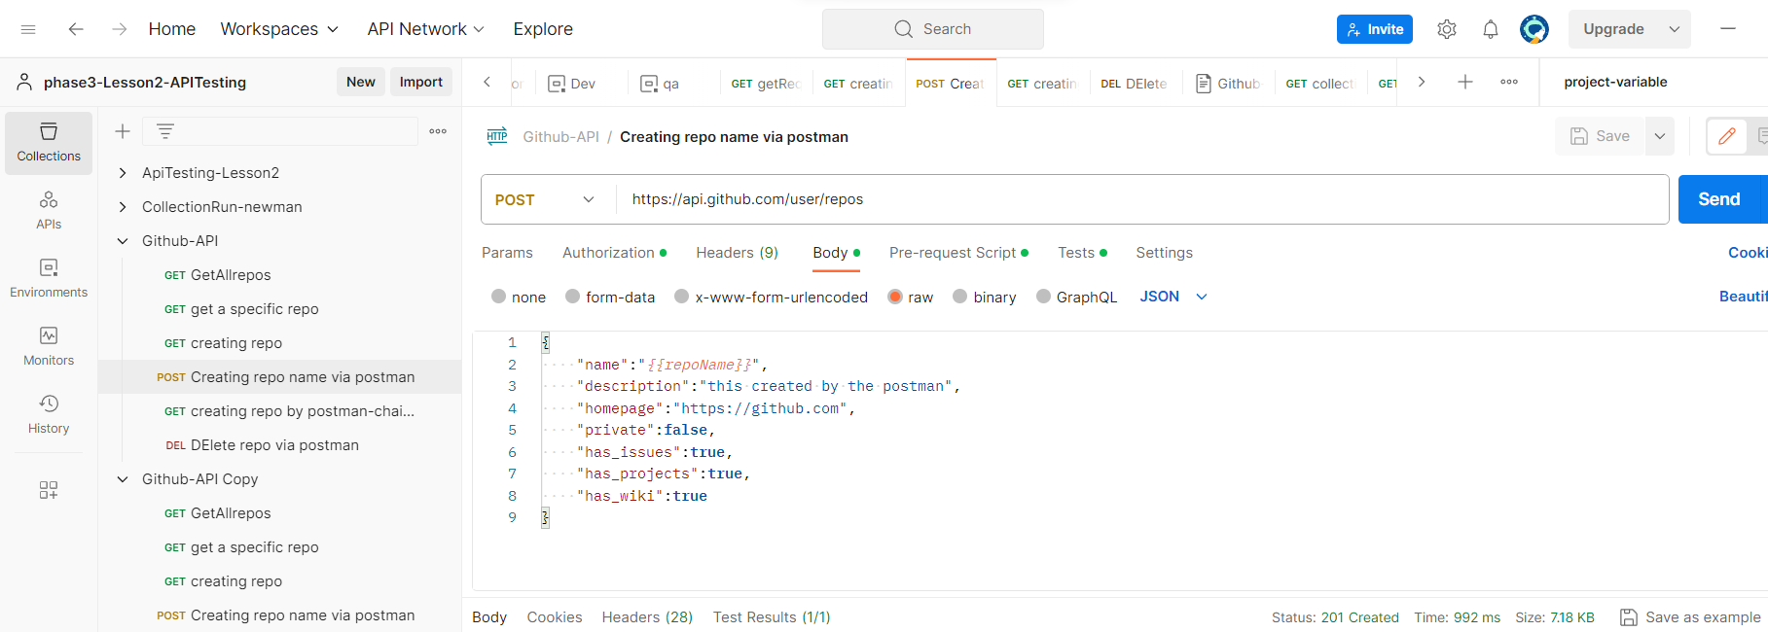

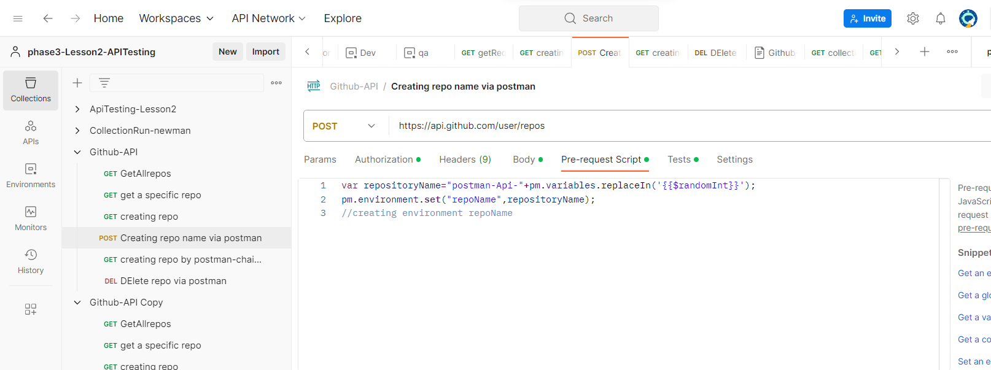

In pre-request we created a environment variable as “repoName”

These two variable are shown in environment once we press send button.

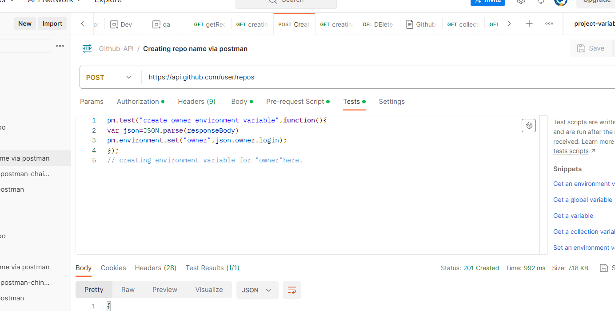

**Click on send button**

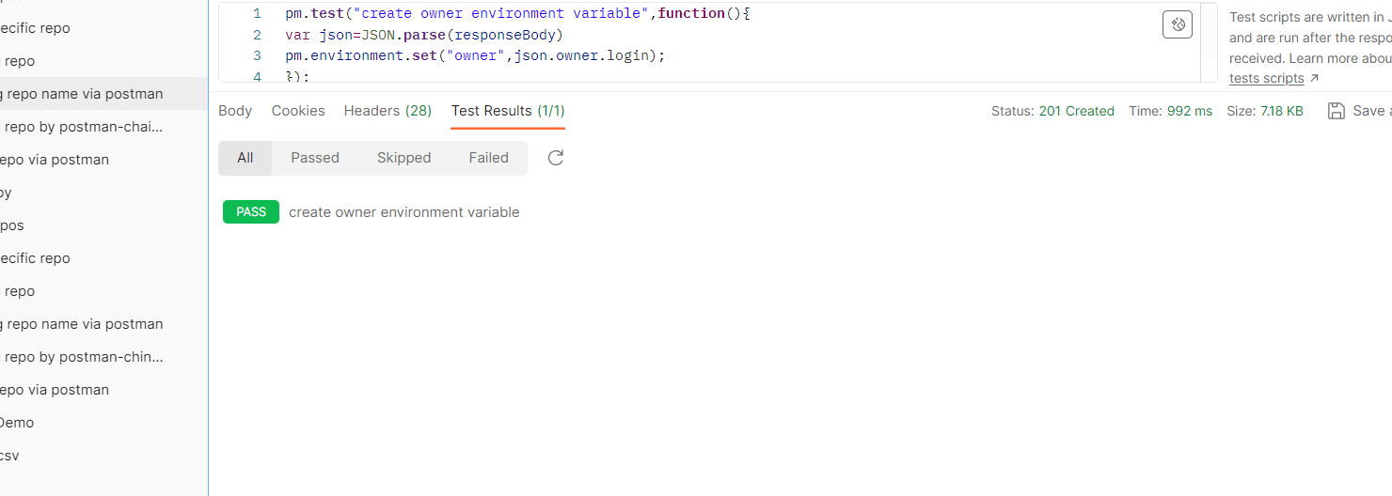

**Then create a another request .**

**Then call the environment variable which is created before (chaining method)**

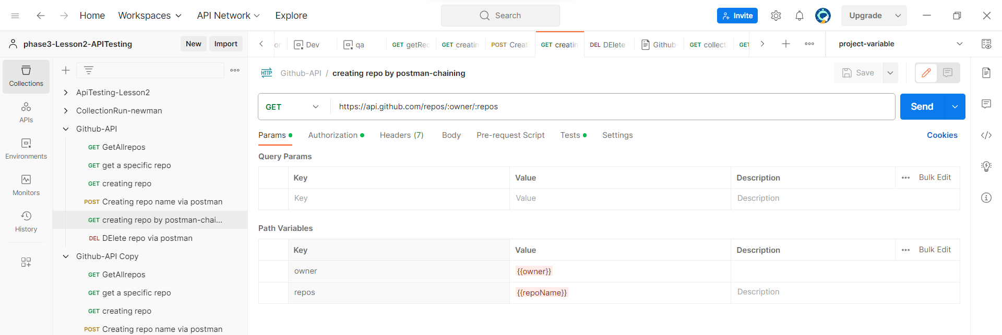

**Assertion code is written in tests.click on send button to see the output**

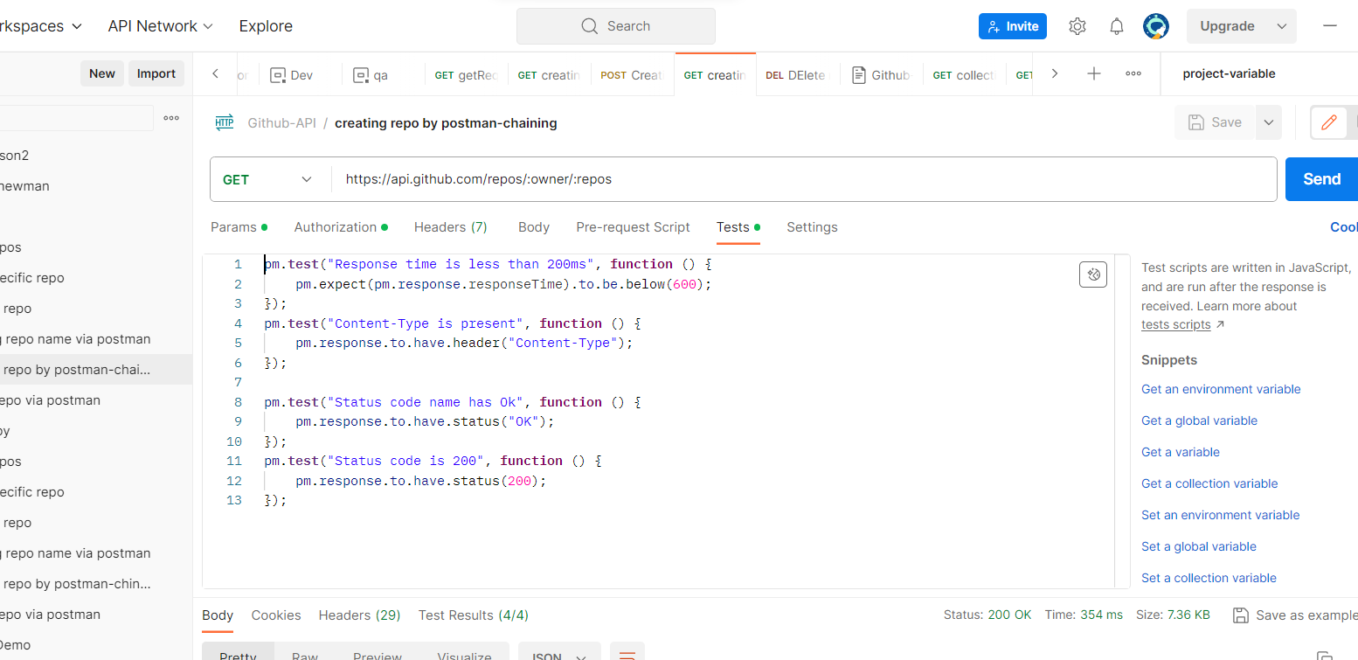

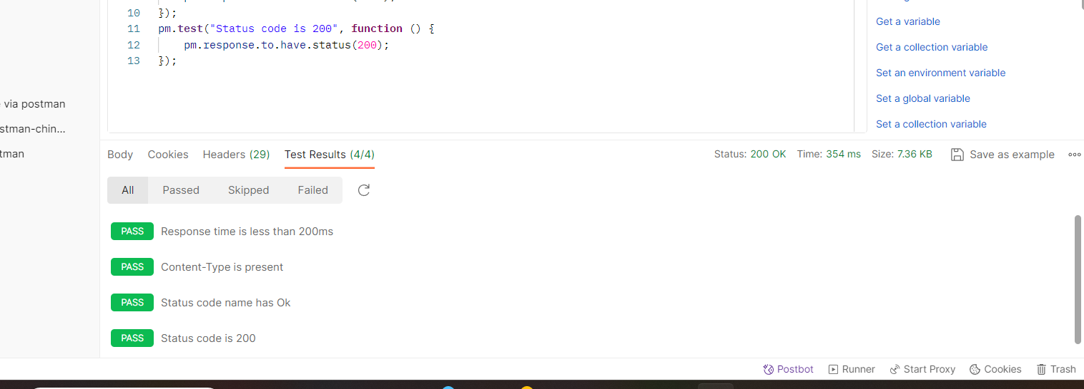

**Creating another request in collection.**

**Selected method-delete,here we are deleting the repo which we are created.**

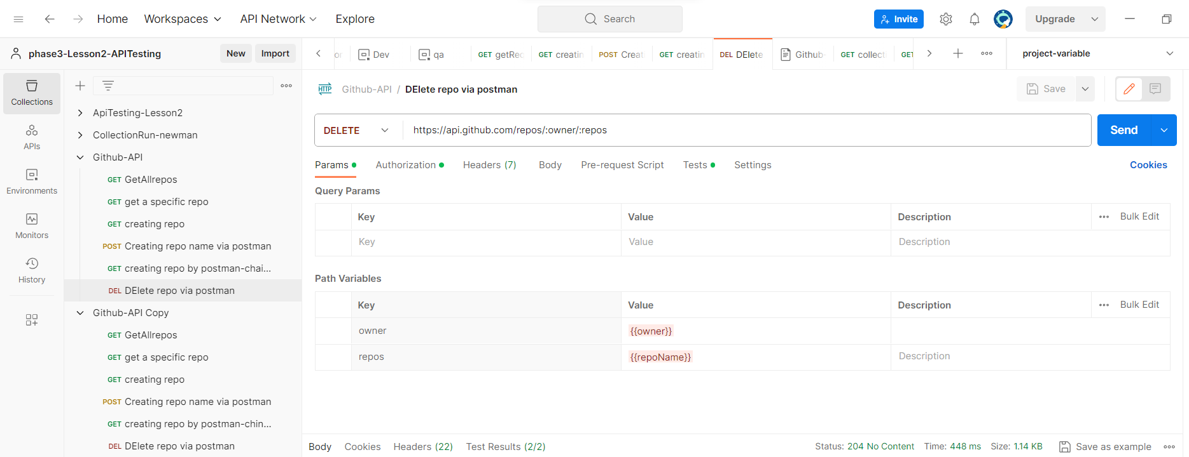

**Click on send button.**

